Annex 2:

Climsoft Open Source – Draft Management, Roles and Responsibilities

(An example ‘Github’ website where governance information, and software, can be stored and managed is http://scitools.org.uk/index.html )

Aim:
To promote and maintain effective management of national climate data in line with best practice and relevant scientific and technical recommendations, through the Climsoft Climate Data Management System, recognising that the national climate data of every Member of WMO is an essential asset both for services now and for all future users.

Approach:
Climsoft is a CDMS developed and maintained through the efforts of the NMHSs of developing countries, which are also the user community of Climsoft.

Climsoft was developed to require only the minimum of licensed commercial software, and not to require any commercial software which would restrict the number of users or the period over which the software works. The move to open source development is expected to further reduce the cost of using the software.

The Climsoft project will be governed with the following approach:
- An active community contributes to the day-to-day development and upkeep of the project.
- The community contributes to decisions through open debate.

Climsoft will be developed using a Plan – Do – Check – Act cycle.
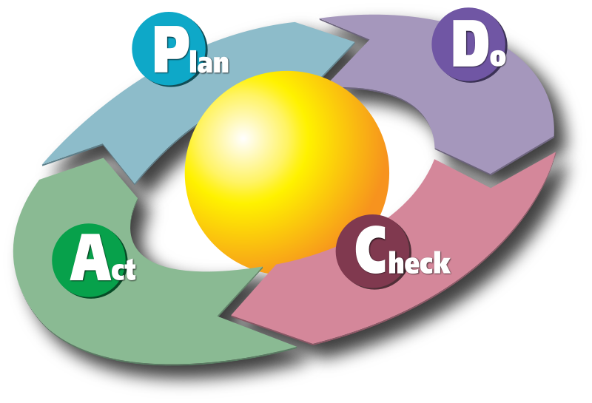

It is the responsibility of all users, contributors, developers and experts to report requirements and problems. These reports will be examined to define the scope of the requirement, and solutions planned, allocated a priority and assigned to contributors or developers. When a solution has been done, it will be checked by the Development Lead for effectiveness and conformance with standards. When it has passed the checks, it will be incorporated into the Core software and made available to users.

Requirements which are local to one national user group will not be incorporated into the Core software unless they are of general interest to a number of user groups in other nations or centres, or can be used as templates for customisation in other nations or centres.

Participation by users, contributors and developers will be positively encouraged, including a process for the development of skills.

Structures and groups

Steering Group (see TORs)
The Steering Group is responsible for the overall direction of the project, and ensuring an appropriate institutional structure. The Steering Group sets the strategic priorities and direction for Climsoft development and use. The Coordinator/Project Manager is an ex-officio member of the Steering Group and reports to it. The Steering Group approves membership of the Technical Advisory Group.
Should meet at least once a year.

Technical Advisory Group
The Technical Advisory Group reports to the Steering Group. The TAG is chaired by the Coordinator/Project Manager and can consist of representatives of the Development Lead, Contributors, Users and other Experts.
The TAG is responsible for:
- maintaining and reviewing the Requirements and Problems list,
- advising the Steering Group on priorities for bug fixes, new code and documentation
- supervising the merging of code and documentation into the Core software
- in conjunction with the Coordinator/PM, monitoring the allocation of work to Developers and Contributors
- Approving coding standards and development methodologies,
- Inviting suitable Contributors to join the Development Lead,
- Asssisting the Cordinator/PM with planning training and capacity development for Contributors and Developers.
- Providing reports to the Steering Group and to Users etc.

Development Lead
The Development Lead for Climsoft are a team of developers coordinated by the Coordinator/Project Manager. It is the Development Lead’s collective responsibility to ensure the quality of the source code and documentation remains high and that the integrity of the project is preserved. To achieve this, the Development lead will:
- Define coding standards
- Define development methodologies
Developers are responsible for reviewing and merging Contributors bug fixes, new code and/or documentation from submitted pull requests into the Core software. They ensure that all code submitted for merging meets the appropriate coding and documentation standards. They also ensure that everyone who wishes to contribute has submitted a ‘Contributor License Agreement’.

Contributors
Contributors are people who contribute to the Climsoft project but do not have sufficient privileges to merge a pull request to the Core software (i.e. Contributors do not have push access to the repository). Contributions can be made by:
- reporting bugs,
- providing bug fixes,
- writing detailed requirements specifications
- adding new code,
- updating or writing new documentation and gallery additions
- participating in testing new code.

Major and effective Contributors to the project will be invited to join the Development Lead group by the Coordinator/Project Manager in conjunction with the TAG.

Users
Users download and use Climsoft. They are the reason the project has been created and developed.

All Users will be encouraged to become Contributors, especially by reporting their problems and experiences with Climsoft, testing bug fixes and writing specifications for new requirements.

